ReactJS – Hands On Learning 01

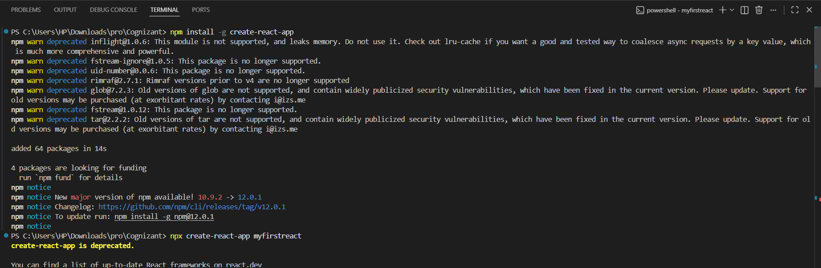
1. Install Create-react-app by running the following command in the command prompt:

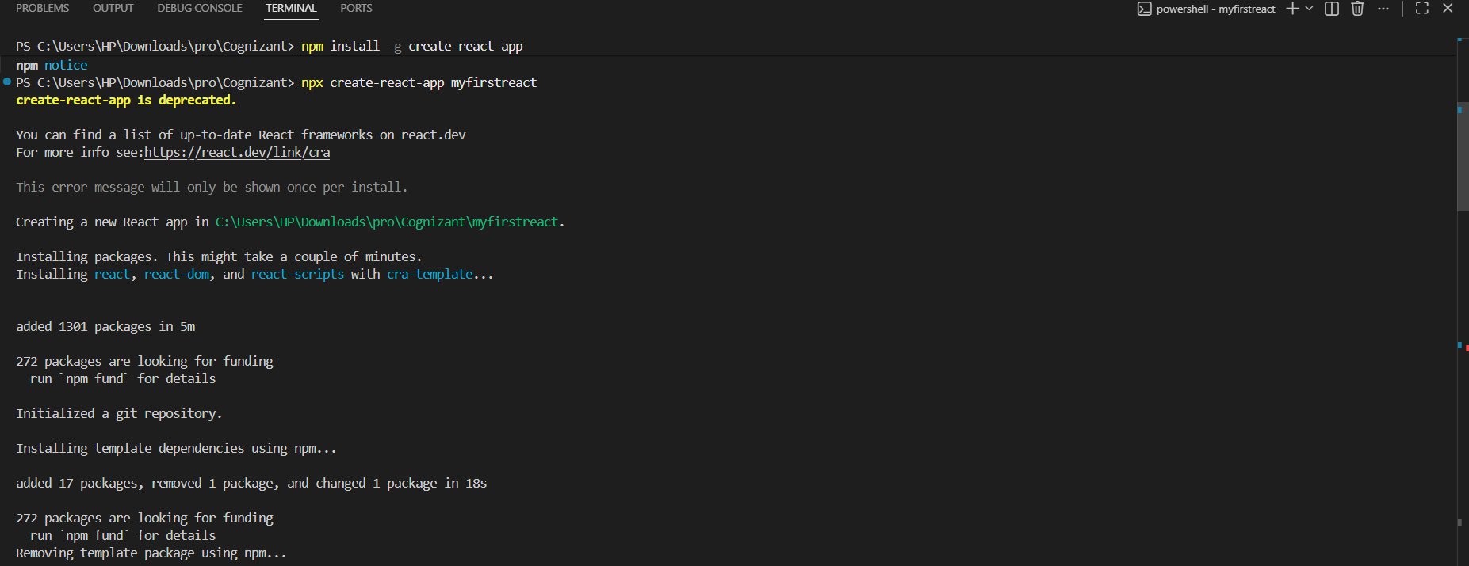
2.To create a React Application with the name of “myfirstreact”, type the following command:

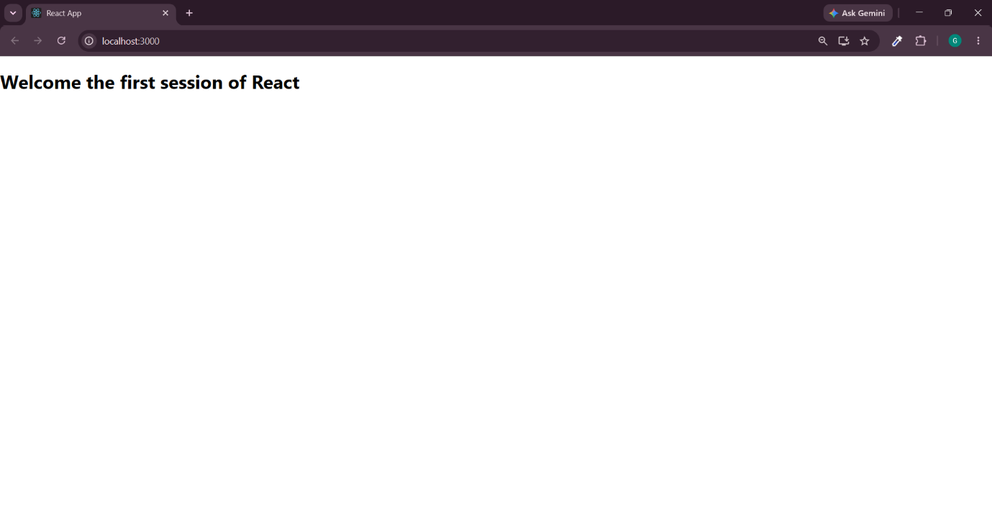
3. Open a new browser window and type “localhost:3000” in the address bar

